**HTML BASICS**

<!DOCTYPE HTML>

<html>

<head>

<tittle style="color:yellow"; > HTML CLASS</tittle>

<style>

a:visited

{

color:yellow;

}

a:unvisited

{

color:green;

}

</style

</head>

<body bgcolor="pink">

<!-- HEADINGS-->

<h1>yoga<h1>

<h2>yoga<h2>

<h3>yoga<h3>

<h4>yoga<h4>

<h5>yoga<h5>

<h6>yoga<h6>

<!--paragraphs <p>, break <br>, under line <u>-->

<!--bolt letters we use <b> or <strong>, itallic we use <i> or <em>-->

<!---break <br> mark or heilight sentence we need to use <mark> </mark>-->

<!--quotes <q>,strike <strike>-->

<p> browsers are the <q>light weight client side </q>software <strike>which </strike>which is used to get a request from <br>the users and render the response from the client</p>

<p> <mark>browsers </mark>are the light weight <u>client side software which is used to get a request from the users and render the response from the client</u></p>

<p> browsers are <b>the light weight client side software<b> which is used to get a request from <strong>the users and render the response from the client</strong></p>

<p> browsers are <i>the light weight client side software </i>which is used to get a request from <em>the users and render the response from the client</em></p>

<!--links external,internal-->

<p>internal link</p>

<a href="log.html">click here</a >

<p>external link</p>

<a href="http://www.google.com">google</a>

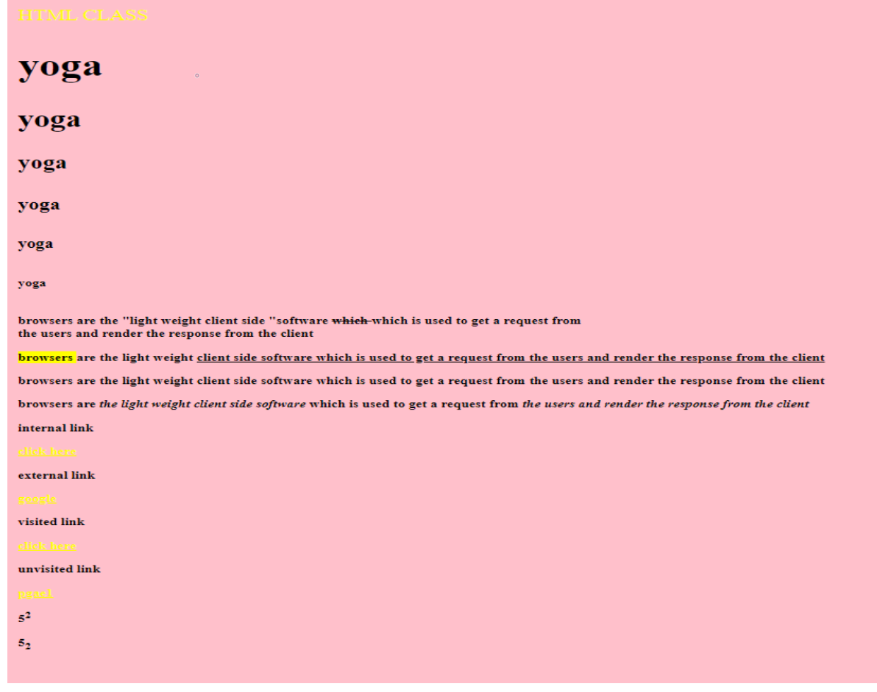<p> visited link </p>

<a href="log.html">click here</a>

<p> unvisited link </p>

<a href="page1.html">pgae1</a>

<!--how to write powers -->

<p>5<sup>2</sup></p>

<p>5<sub>2</sub></p>

</body>

</html>

**TO CREATE TABLES IN HTML**

PAGE1.HTML

<!DOCTYPE html>

<html>

<head>

<tittle> TABLES </tittle>

</head>

<body>

<table border=1>

<caption align="top" > my table</caption>

<thead align="left" bgcolor="blue">

<tr>

<th> heading1</th>

<th> heading2</th>

</tr>

</thead>

<tbody bgcolor="red">

<tr>

<td> fiirst column</td>

<td> second column</td>

</tr>

<tr>

<td> fiirst column</td>

<td> second column</td>

</tr>

<!--rowspan and colspan-->

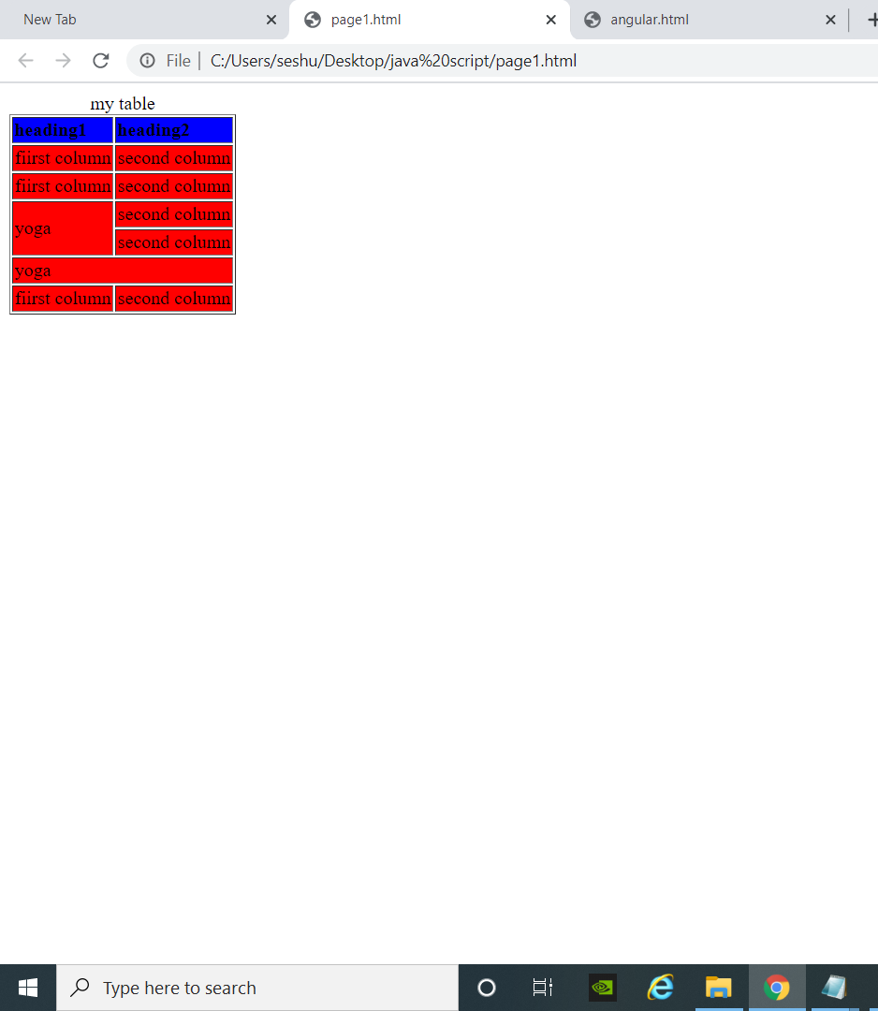<tr>

<td rowspan=2> yoga </td>

<td> second column</td>

</tr>

<tr>

<td> second column</td>

</tr>

<tr>

<td colspan=2> yoga </td>

</tr>

<tr>

<td> fiirst column</td>

<td> second column</td>

</tr>

<tbody>

</table>

</body>

</html>

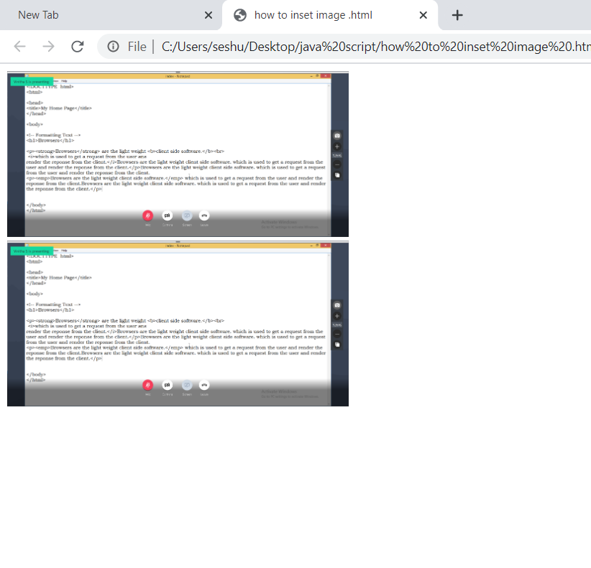 **INSERT IMAGES IN HTML AND IMAGE LINKING  
log.html**

<!DOCTYPE HTML>

<html>

<head>

<tittle> IMAGES </tittle>

</head>

<body>

<!--inserting images-->

<img src="GoToMeeting 000.png" width="25%" >

<br>

<!--image linking-->

<a href="https://www.google.com"><img src="GoToMeeting 000.png" width="25%"></a>

</body>

</html>

“CLICKING THE SECOND IMAGE WILL GIVE THIS RESULT”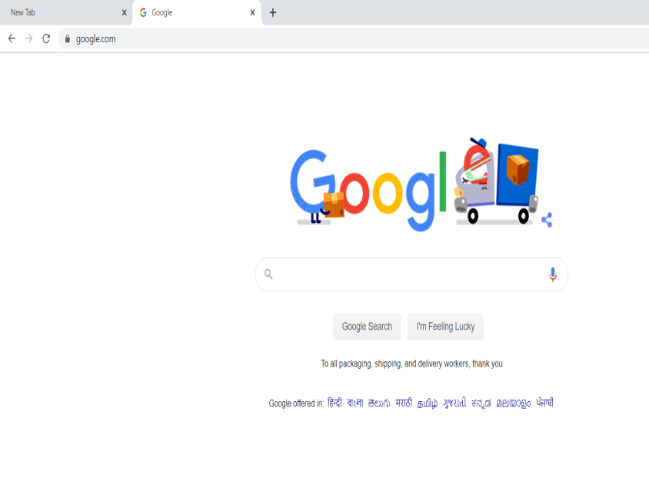

**Frames in html**

**Framelinker.html**

<!DOCTYPE HTML>

<html>

<head>

<tittle></tittle>

</head>

<body>

<iframe width="560" height="315" src="https://www.youtube.com/embed/8MGLFATwvQE?start=1" frameborder="0" allow="accelerometer; autoplay; encrypted-media; gyroscope; picture-in-picture" allowfullscreen></iframe>

<br>

<iframe width="500" height="500" src=frameA.html></frame>

</body>

</html>

**frameA.html**

<!DOCTYPE HTML>

<html>

<head>

<tittle></tittle>

</head>

<body>

<iframe width="400" height="400" src=frameB.html></frame>

</body>

</html>

**frameB.html**

<!DOCTYPE HTML>

<html>

<head>

<tittle></tittle>

</head>

<body>

<a href="history.html" target=_self> history click here</a><br>

<a href="history.html" target=_parent> history click here</a><br>

<a href="history.html" target=_blank> history click here</a><br>

<a href="history.html" target=_top> history click here</a><br>

</body>

</html>

**history.html**

<!DOCTYPE HTML>

<html>

<head>

<tittle style="color:red">History <br></tittle>

</head>

<body>

History (from Greek ἱστορία, historia, meaning 'inquiry; knowledge acquired by investigation')[2] is the past as it is described in written documents, and the study thereof.[3][4] Events occurring before written records are considered prehistory. "History" is an umbrella term that relates to past events as well as the memory, discovery, collection, organization, presentation, and interpretation of information about these events. Scholars who write about history are called historians.

History also includes the academic discipline which uses a narrative to examine and analyse a sequence of past events, and objectively determine the patterns of cause and effect that determine them.[5][6] Historians sometimes debate the nature of history and its usefulness by discussing the study of the discipline as an end in itself and as a way of providing "perspective" on the problems of the present.

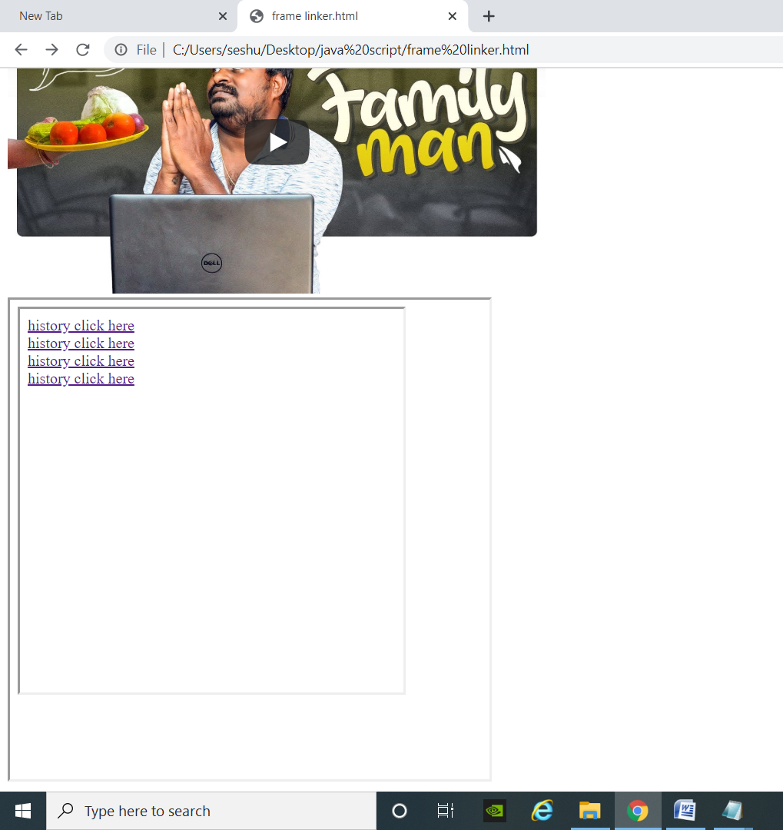</body>

</html>

**FRAME SETS**

**Framesets.html**

<frameset cols="25%,50%,25%">

<frame src="page1.html">

<frameset cols="25%,25%">

<frame src="history.html">

<frame src="page1.html">

</frameset>

<frameset cols="15%,10%">

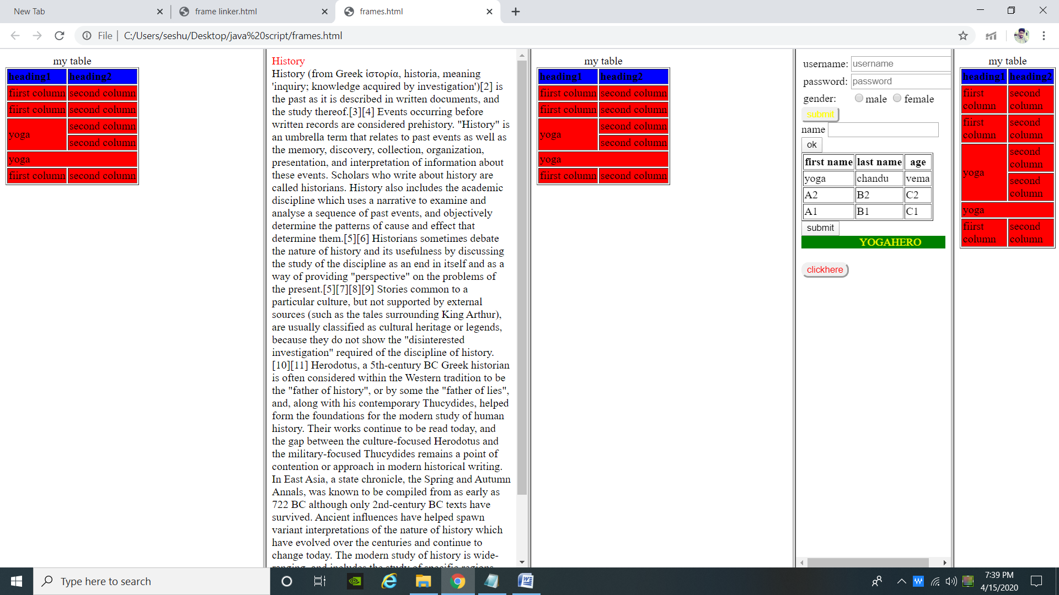<frame src="log.html">

<frame src="page1.html">

</frameset>

</frameset>

**To crate forms**

<html>

<head>

<tittle>

</tittle>

</head>

<body>

<form>

<center>

<fieldset>

<legend> Login Details

</legend>

<table>

<tr>

<th colspan="2">Registration form</th>

</tr>

<!--To create user name -->

<tr>

<td><label for="username">username</label></td>

<td><input type="username" name="username" id="username"

autofocus="on" autocomplete="off" maxlength="10" placeholder="type username" required></td>

</tr>

<!--To create password -->

<tr>

<td><label for="password">password</label></td>

<td><input type="password" name="password" id="password" placeholder="type password"></td>

</tr>

<!--To create address -->

<tr>

<td><label for="address">Address</label></td>

<td><textarea name="address" id="address" col="20" row="15" style="resize:none"></textarea></td>

</tr>

<!--to create buttons-->

<tr>

<td><input type="submit" value="submit"></td>

<td><input type="reset" value="reset"></td>

</td>

</table>

</fieldset>

<fieldset>

<table>

<legend> how to create radio buttons,check buttons</legend>

<tr>

<td><label for="favrcolor">select your colors</td>

<td><input type="checkbox" name="favcolor" value="blue" checked>blue</td>

<td><input type="checkbox" name="favcolor" value="red">red</td>

<td><input type="checkbox" name="favcolor" value="green">green</td>

<td><input type="checkbox" name="favcolor" value="black">black</td>

</tr>

<tr>

<td><label for="choose one">select your gender</td>

<td><input type="radio" name="gender" value="male">male</td>

<td><input type="radio" name="gender" value="female">female</td>

</tr>

<!--how to create options-->

<tr>

<td><label for="options">select your country</td>

<td>

<select>

<option>choose an option</option>

<option value="india">india</option>

<option value="usa">usa</option>

<option value="China">china</option>

</select>

</td>

</tr>

<!--datalist-->

<tr>

<td><label for="department">select your department</td>

<td><input list="department" /td>

<td>

<datalist id="department">

<option>department</option>

<option value="CSE">CSE</option>

<option value="EC">EC</option>

<option value="EEE">EEE</option>

<option value="MECH">MECH</option>

<option value="BIO">BIO</option>

</datalist>

</td>

</tr>

<!--how to upload a file-->

<tr>

<td>please upload a file</td>

<td><input type="file" value="upload"></td>

</tr>

</center>

</table>

</fieldset>

</html>

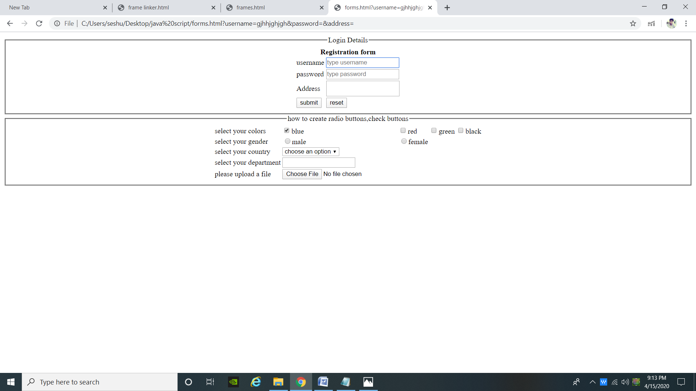

**lists**

<html>

<head>

<tittle>

</tittle>

</head>

<!--unorder list, horizantal line <hr>,-->

<h1>grocery</h1>

<ul type="square">

<li>Coffee</li>

<li>Tea</li>

<li>Milk</li>

<li>wheat</li>

</ul>

<hr>

<!--order list-->

<h1> order list</h1>

<ol type="A" start=5>

<li>Coffee</li>

<li>Tea</li>

<li>Milk</li>

<li>wheat</li>

</ol>

<hr>

<!--detailed list-->

<h1>detailed list</h1>

<dl>

<dt>coffee</dt>

<dd>-500mg</dd>

<dd>-hot</dd>

</dl>

<dl>

<dt>academic</dt>

<dd>-top 5 universities</dd>

<dd>-top 5 students</dd>

</dl>

<hr>

<!--mixed ul,ol,dl-->

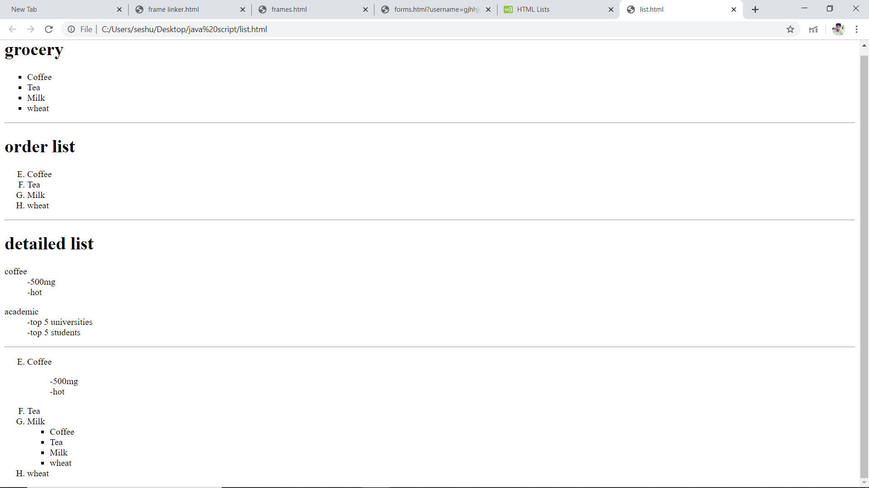<ol type="A" start=5>

<li>Coffee</li>

<dl>

<dd>-500mg</dd>

<dd>-hot</dd>

</dl>

<li>Tea</li>

<li>Milk</li>

<ul type="square">

<li>Coffee</li>

<li>Tea</li>

<li>Milk</li>

<li>wheat</li>

</ul>

<li>wheat</li>

</ol>

</html>